Midterm – DC Crashes Analysis
ALY 6070: Communication and Visualization for Data Analytics
Date: 07/29/2025
Instructor: Professor Jack Bergersen
Term: Summer 2025
Group 2:
Ruman Liu
Junhui Hu

Introduction
For our midterm project in ALY6070, we focus on analyzing traffic crash data in Washington, D.C. to identify spatial and severity-based patterns. Traffic safety has always been a critical issue in urban environments, and visualizing crash data can uncover insights that help city officials make informed decisions. Our analysis leverages Tableau to create interactive dashboards that highlight where accidents occur most frequently and how severe they are.
The primary objective of this project is to identify crash hotspots and understand the distribution of crash severity levels across the city. By exploring spatial data, such as crash locations using latitude and longitude, and categorical data like severity level, we aim to answer four core research questions.
- How Do Day/Night, Year Category, Impairment, and Speeding Relate to Crash Geography?
- Which Streets or Areas in DC Experience the Highest Number of Traffic Crashes?
- During Which Months Do Different Severity Levels Peak?
- Which Types of Vehicles Contribute Disproportionately to Crashes?
This data-driven approach provides both a macro and micro-level understanding of traffic incidents, which is essential for improving public safety and optimizing traffic management policies.

Research Question 1
For this question, we designed a density map focusing on the most severe incidents. In Tableau I placed Longitude on Columns and Latitude on Rows, chose Density from the Marks card, and applied Severity_Level, year_date, day_night, Impaired, Speeding_Involved, Ward and NearestStreetName as filters. Most of the fields were calculated field based on the old data structure.
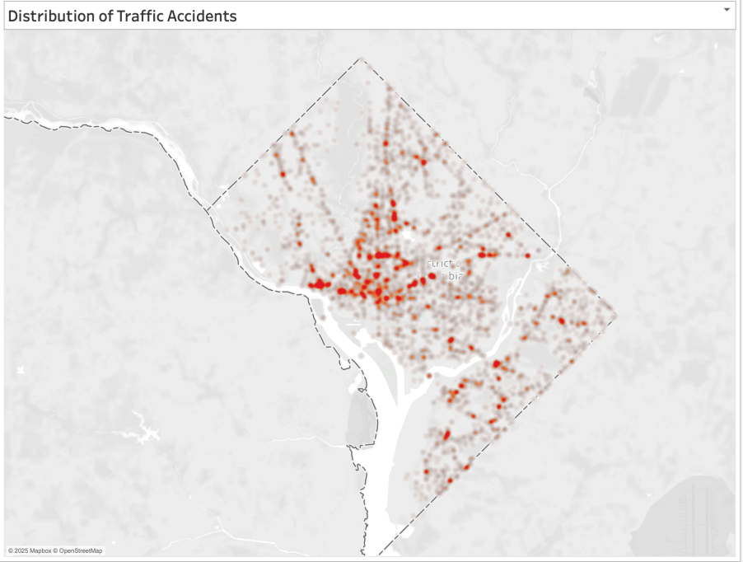
Figure 1: Distribution of Traffic Accidents.
This visualization helps answer our first research question: How Do Day/Night, Year Category, Impairment, and Speeding Relate to Crash Geography? By plotting over 4,000 records using the Latitude and Longitude fields, we visualized the crash distribution across the city which uses gradient color encoding to represent crash intensity. Darker red areas correspond to higher concentrations of incidents.
Temporal and contextual filters reveal that crash recordings before 2000 are scarce, likely due to less digitized record-keeping and lower vehicle ownership, so direct comparisons should focus on 2000–2010 and post-2010 data. Impaired-driving flags appear mostly after 2010 and concentrate at night, indicating both improved reporting and the well-documented risk of nighttime intoxication. Geographically, these impairment-related crashes cluster around entertainment districts rather than commuter corridors. For speeding, post-2010 crashes are spatially dispersed, which often occurring on peripheral arterial roads rather than the downtown grid. This pattern may reflect higher posted speeds and fewer traffic controls outside the city center, suggesting that speed-management strategies might yield the greatest benefit on DC’s outer thoroughfares.
In terms of design decisions, we chose the density map for its ability to intuitively convey spatial intensity without overwhelming users with individual data points (Ware, 2012). The color scale was adjusted to highlight differences between low- and high-density areas, allowing for rapid pattern recognition. In future iterations, we plan to overlay this map with severity-level categories or dynamic tooltips to provide richer context.

Research Question 2:
Which Streets or Areas in DC Experience the Highest Number of Traffic Crashes?
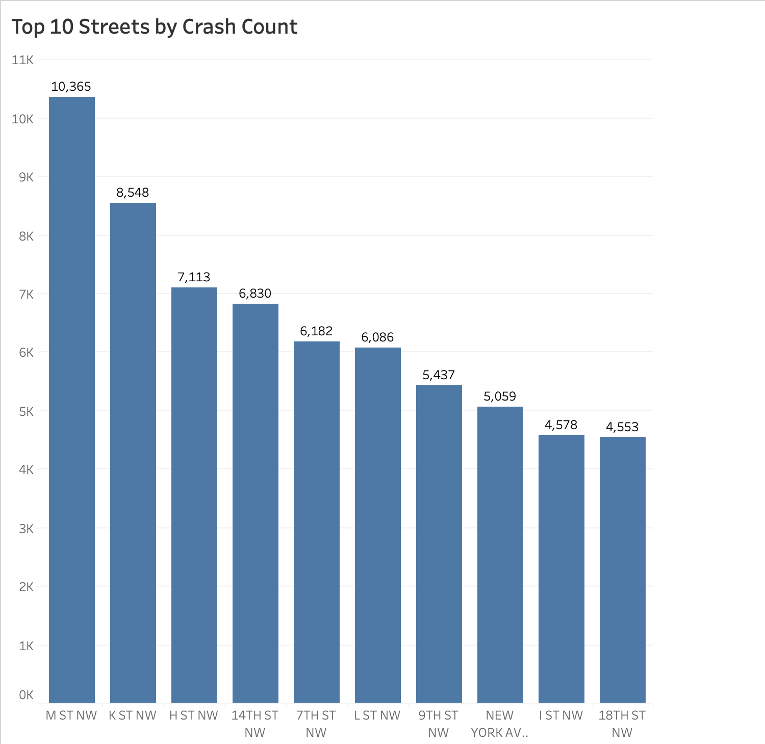
Figure 2. Bar chart of the Top 10 D.C. streets with the highest total crash counts.
To identify hotspot corridors, we created a bar chart of the top ten streets by crash count (figure 2). In Tableau, we placed NearestStreetName on Columns and used COUNTD(CCN) on Rows, then sorted descending and filtered to the first ten members. The resulting chart shows that M Street NW leads with 10,365 crashes, followed by K Street NW (8,548) and H Street NW (7,113). Because these arterials carry both heavy commuter and commercial traffic, their high intersection density likely contributes to more conflict points and collisions.
Research Question 3:
During Which Months Do Different Severity Levels Peak?
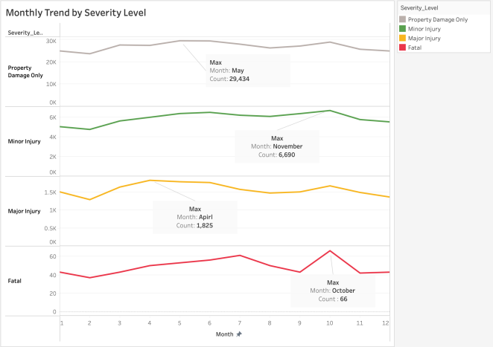
Figure 2. Monthly crash counts by severity level.
To examine seasonal patterns, we built a small-multiples trend chart where each severity level has its own Y-axis scale to avoide distortion from the wide range between property-damage counts and fatalities. Specifically, we placed month on Columns and severity_level on Rows, with COUNTD(CCN) on the vertical axis. In the Marks card, we selected line and colored by severity. Then edited each pane’s axis independently to fit its data range, ensuring that patterns in the lower-count fatality line remain visible alongside the high-volume property-damage line.
We observed distinct seasonal patterns, property-damage-only crashes reach their maximum in May, which suggest that spring travel and better weather encourage more driving but perhaps at moderate speeds. Minor injuries peak in November, which may coincide with changing daylight and weather conditions. Major injuries are highest in April, this possibly driven by increased speeding before summer. Fatal crashes peak in October, a month with rapidly shortening daylight and perhaps more risky behavior during fall events.

Research Question 4:
Which Types of Vehicles Contribute Disproportionately to Crashes?
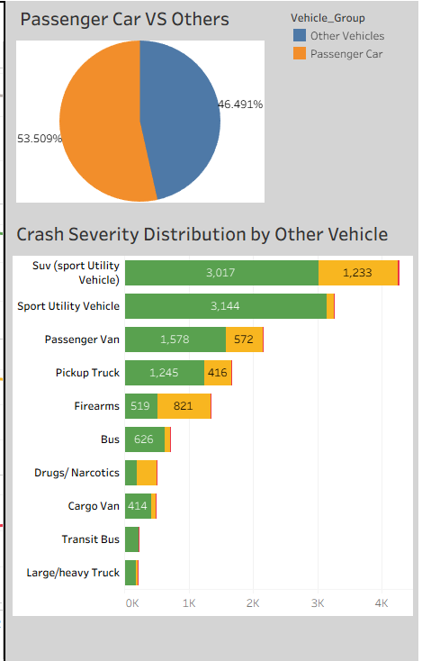
Figure 4. Pie chart
When we first checked the data, we noticed that passenger cars showed up in a little over half of all crashes—about 53.5 %. That big share made us curious about what came next, so we built a bar chart that left out passenger cars and compared the rest. The chart showed that sports cars and SUVs were clearly the second- and third-largest groups. Even though there are fewer sports cars on the road, they still caused a high number of minor and major injuries. It makes sense, because sports cars are designed for speed and some drivers push them too fast on city streets. SUVs also had a large crash count, likely because they are heavier and sit higher off the ground, which can lead to rollovers or stronger impacts. From this, it looks like passenger cars need the broadest safety focus, while sports cars and SUVs deserve extra attention for speed and stability issues.

Conclusion
The dashboard simplifies the crash dataset to communicate possible insights to stakeholders. From a spatial view, problem corridors such as M Street NW and K Street NW are easily identified. Targeted road design changes in these corridors may help in decreasing the crash frequency. The time pattern shows different peaks in number of crashes by severity level, implying a refocus of public-safety messaging as the year goes on. Vehicle-type distributions show a different risk exposure as passenger cars are the cause of most crashes, but sports cars and SUVs make up an outsized proportion of serious injuries. The density plot highlights two distinct risk profiles, one from impaired driving and nighttime downtown concentration, and one from speed-related crashes along outer arterials. Overall, these results may allow planners and police to target where and when resources may have the most impact.

References
Few, S. (2009). Now You See It: Simple Visualization Techniques for Quantitative Analysis. Analytics Press.
Ware, C. (2012). Information Visualization: Perception for Design (3rd ed.). Morgan Kaufmann.

